Power BI Assignment 4

1. Make a simple dashboard and show columns, bar charts, line charts, and area charts.

Answer: 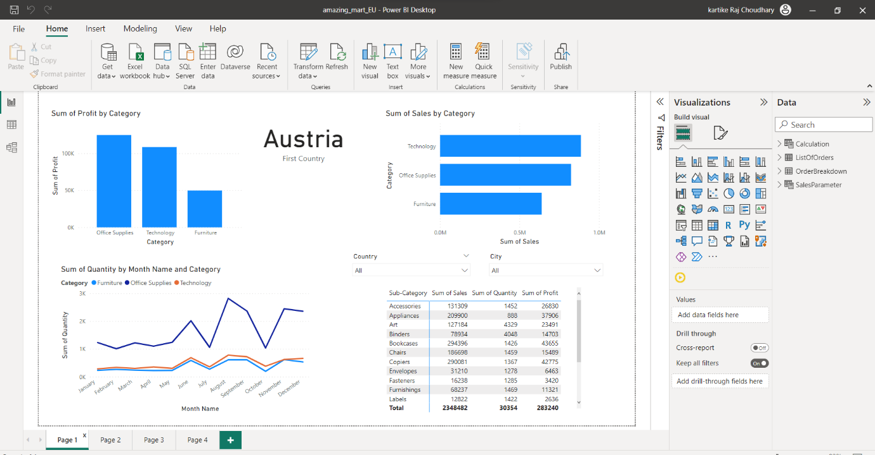

1. Make a simple dashboard and show combination chart, Scatter chart, Shape chart, and Tree map chart.

Answer:

